**Creating a DSN Connection**

**Start > Control Panel > Administrative Tools > Data Sources (ODBC)**

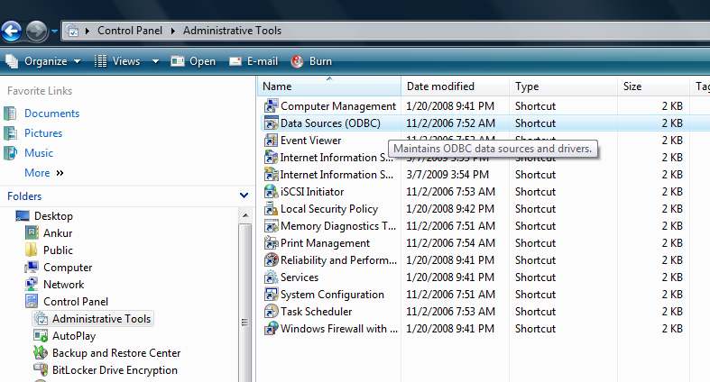

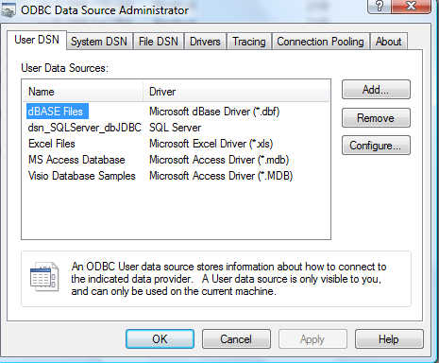

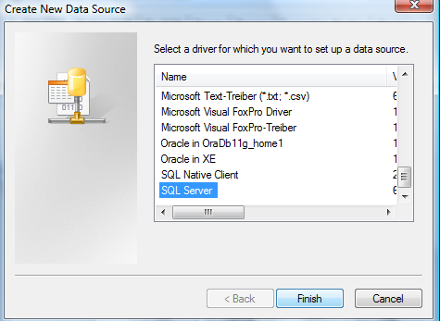

**Type the name of the datasource as :**

**Dsn_SQLServer_dbJDBC**

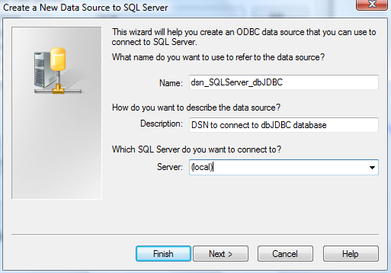

**Select ‘SQL Server Authentication’**

**Provide the username and password to connect to the database.**

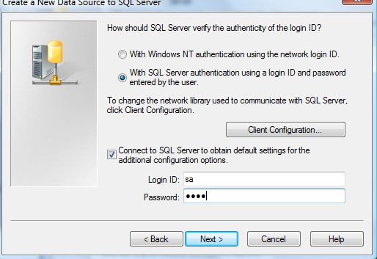

**Change default database to ‘dbJDBC’**

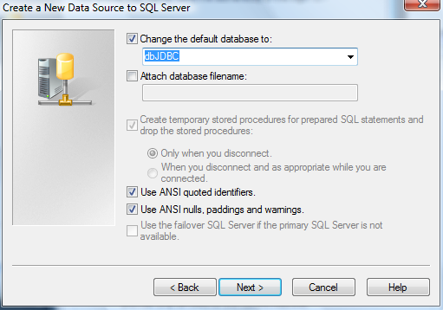

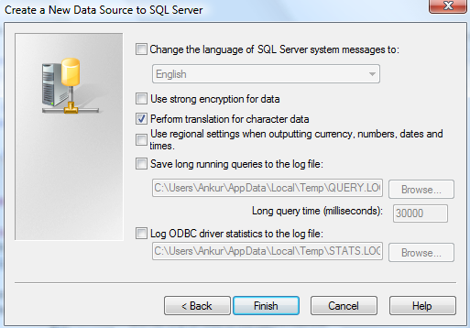

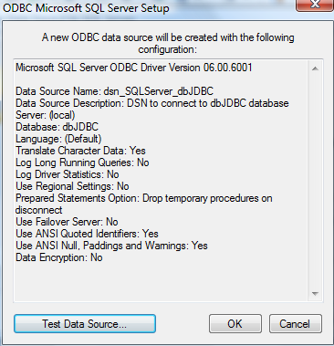

**Click the ‘Test Data Source’ button to test your connectivity.**

